Selfless heroes battling health emergencies in flood catastrophe
In the face of a devastating flood emergency in Pakistan, frontline vaccinators bravely reach out to communities with lifesaving health services.

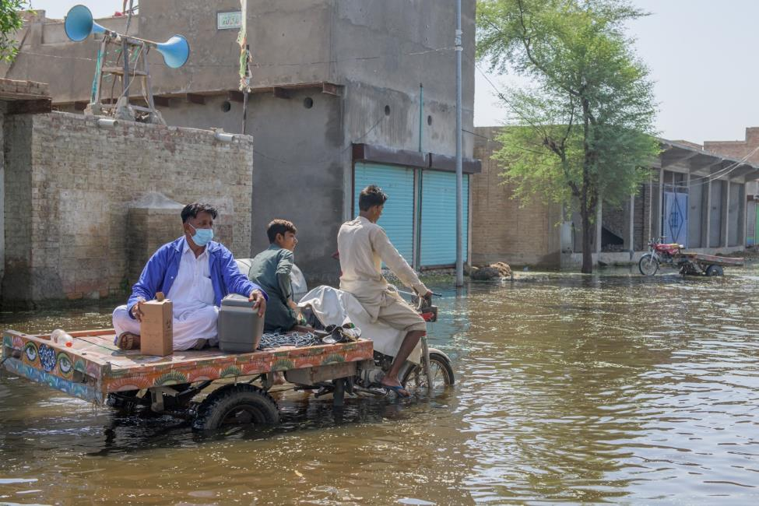

Background
Vaccinating children against life-threatening diseases amid a devastating flood can be daunting. Vaccinators in Sindh have endured difficult journeys, manured flooded villages, and crossed broken bridges to reach children who have been exposed to a series of health outbreaks since the August flood. Their efforts have been challenged by the difficult conditions, as the flooded areas remain submerged in sea-like water.
Floods have disrupted routine immunization services, surveillance efforts, and the cold chain. The risk of vaccine-preventable disease outbreaks remains very high. Sindh province reported the highest number of outbreaks, 22, followed by 18 outbreaks in KPK, 17 in Punjab, and 7 in Balochistan. However, Punjab province reported the highest outbreak related cases 931(59%).
Sindh province also reported the highest number of deaths, 24, which is 63 % of the total outbreak-related deaths reported in the country(N=38). This is attributed to poor vaccination coverage in some flood-affected districts and population displacement due to floods. There is an equal risk of outbreaks of other vaccine-preventable diseases.
Furthermore, Pakistan is amongst the top ten countries with a larger pool of un / under-vaccinated children in the world and is home to more than 600,000 zero-dose children. The recent flood has caused a significant drop in routine immunization services, especially in the 84 affected districts. Major immunization service delivery interruptions have been reported in Balochistan and Sindh provinces.
According to the National Disaster Management Authority (NDMA), 2,000 health facilities, representing 10% of the country's health facilities, have been damaged or destroyed. Also, a preliminary assessment by WHO and the Provincial EPI Program indicates that 738 of 8,632 (9%) EPI centres are damaged across 84 flood-affected districts, with 223 (30%) fully damaged and the remaining 513 partially damaged)
Response
The flood water has complicated vaccinators' work. Inaccessible, damaged public health facilities have disrupted routine immunization services and newborns missed out first crucial vaccine and many more likely in the coming weeks.
As per the special instructions of Honourable Federal Health Minister, Mr. Abdul Qadir Patel and direct supervision of Dr. Muhammad Ahmad Kazi, DG, Federal Directorate of Immunization (FDI), partners prepared an emergency flood response to vaccinate children with Mr vaccine while ensuring routine immunization without any disruption in IDP settlements and adjacent flood-affected areas.
Nizam ud din is one of the vaccinators committed to providing medical care on the humanitarian frontlines. Every day, he teams up/sets out with a team assistant to reach out to unvaccinated children in the villages of Gambat, District Khairpur, located about 70 kilometres from the main city. However, getting to the remote, flooded village is a challenging task. Nizam and his colleagues must find out a suitable commute to get to children and their families who have either relocated or found shelter at the relief camps.

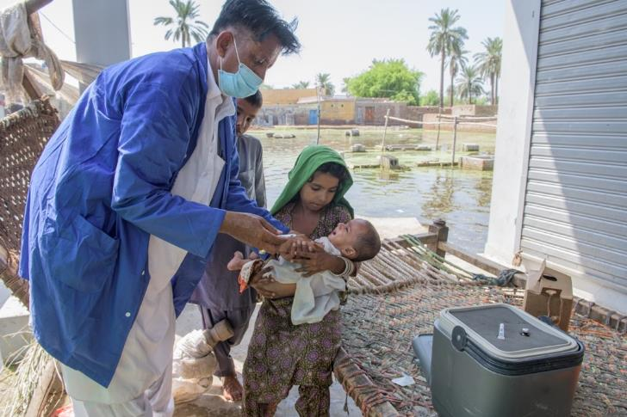
In addition to reaching the internally displaced population (IDPs), Nizam is part of the mobile health services team who provides basic health and routine immunization services to the displaced population. The flood damaged health infrastructures and choked the delivery of lifesaving.
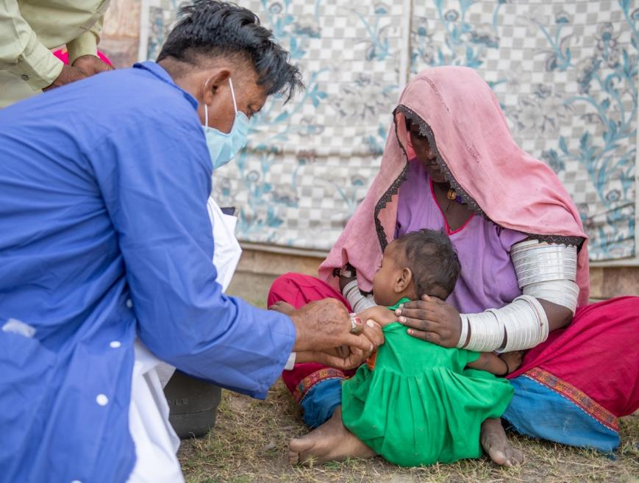
"When we set out in the morning to reach out to unvaccinated children." A large number of families are on the move and have taken refuge in IDP camps. We're unsure whether our transportation will be adequate to get us to the destination because most roads are either damaged or submerged. We prepare and wade through to the target households. Upon reaching the villages, we validate our existing information and, if required, update our data sheets. Usually, we manage to vaccinate 20 children every day. Children of age more than six months receive the Measles-Rubella vaccine besides nutritional assessment," Nizam says

"This vaccine will protect your children from infections and viruses," Nizam tells the parents who came to the mobile health camp. "If your child catches virus and becomes sick, the whole family will suffer because you have to take care of the child instead of reclaiming your flood home or resuming your livelihood."
Dr Ahmed Kazi, Director General, FDI, convened serval meetings with partners and donors to chalk out a comprehensive plan with provincial EPI's for the continuation of routine immunization in flood-affected areas and through the outreach team's implementation of the MR campaign. Dr Kazi emphasized the need for integrated health services with routine immunization. "The children are vulnerable in the IDP camps and more susceptible to vaccine-preventable diseases. Health centres have been flooded, their supplies damaged, and people have moved away from home, which makes it harder for them to access their normal health services', Dr Kazi added
FDI, together with provincial EPIs and partners, has scaled up support for immunization by providing vaccines for children at the doorstep of flood-hit communities and establishing emergency health camps to safeguard them from diseases such as malaria, diarrhoea and respiratory tract infections.
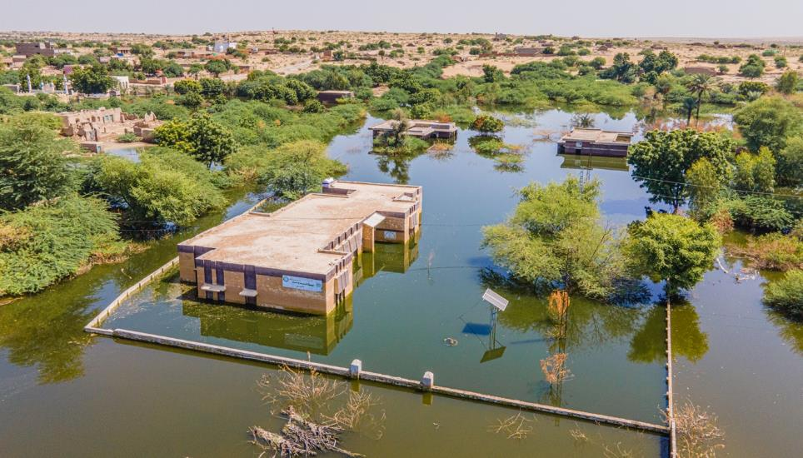
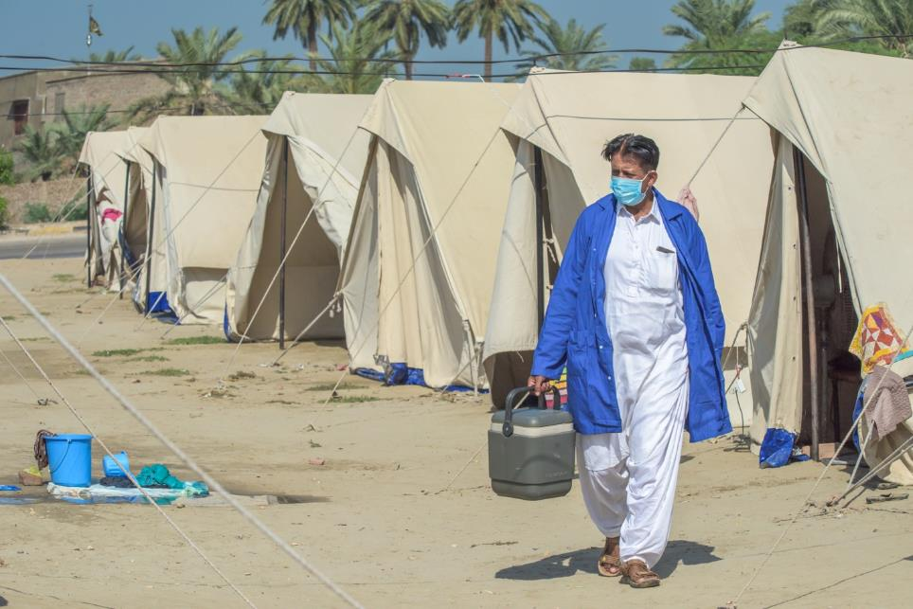
"The health camps are critical when millions, particularly children, are extremely vulnerable to outbreaks", Dr Kazi highlighted. With children living on the brink of multiple diseases and widespread malnutrition, they face an extremely high risk of disease. Moreover, in Sindh, over 10% of health facilities in 15 districts are fully or partially damaged, and the health system is on the verge of collapse.
With the health system hanging in the balance, such campaigns are helpful in providing initial relief but are not sustainable. These interventions alone cannot address the medical needs of the entire population once the flood water retreat. A structured building back better approach to health systems recovery is needed to ensure that the rebuilt public system is stronger, safer, agile and more resilient to disasters.

